# Einstein Solid

In this class, we will be focused on a model called the *Einstein solid* model of simple crystalline solids, particularly those where the atoms are arranged in simple cube-based structures such as table salt (NaCl) and copper as shown in Figure **A**. This model, named after Albert Einstein, is like the ideal gas law discussed in the previous section: almost no solid behaves exactly like an Einstein solid. However, the behavior of many solids is approximately Einsteinian and the principles behind the model can be used successfully to understand the more complex solids that you will probably study in your other science courses.

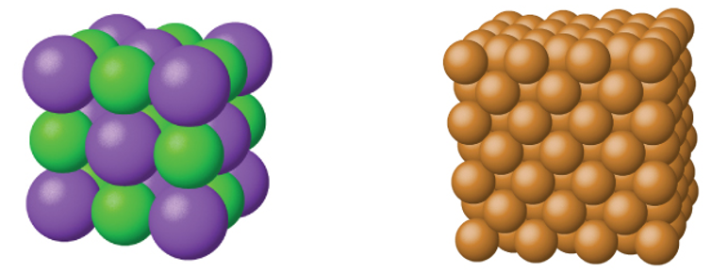

*Figure* ***A****: Both table salt (NaCl) on the left and solid copper on the right are simple crystalline solids with a cube-based structure.*

In the Einstein solid model, we model the bonds between each atom as tiny springs that obey the Hooke’s Law F=kx that we discussed in Unit 2. This model is shown in Figure **B**.While chemical bonds, like everything else, do NOT exactly obey Hooke’s Law, the modelling of atomic bonds as springs is very common throughout physics, chemistry, and biology. The reason this model is so common is that, for small shifts, atoms do behave as if they are on springs: pull two atoms in a crystal apart and the atomic bonds will pull them back together. If you push two atoms too close together, then the two positively charged nuclei will repel each other pushing them apart. The result is that each atom vibrates about its equilibrium position or *lattice site* as if it were attached to tiny springs. Given that calculations with Hooke’s Law are so simple to do in comparison to full calculations of atomic forces, you can see why this Einstein model is a useful approximation.

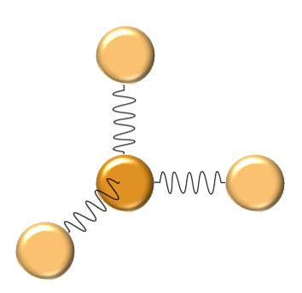

*Figure* ***B****: The model of an Einstein solid, the central atom is connected to its neighbors by atomic bonds that are modeled by springs that obey Hooke’s Law*